Supplementary Material
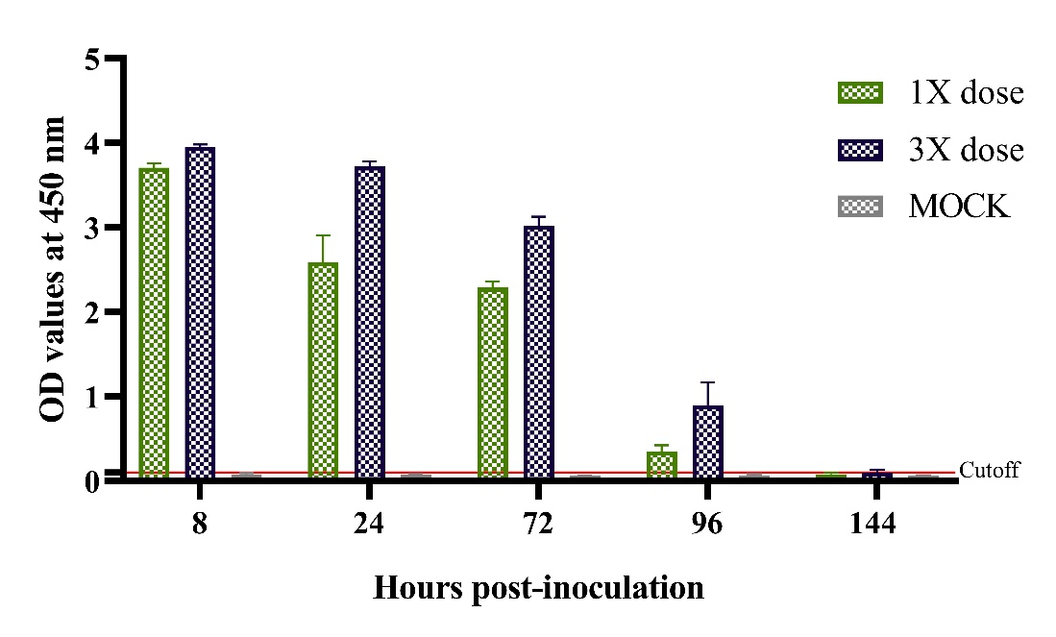
For the evaluation of immediate bioavailability at the systemic level of IgY-R, an intravenous administration of IgY-R was assayed. Mice were distributed in three groups of 6 individuals each, including a group receiving a 1X dose of IgY-R, another receiving a 3X dose of IgY-R, and a group that receives PBS. Blood samples were taken by puncture of the submandibular vein and processed, allowing blood to coagulate at room temperature for 1 h, then centrifugating at 5000 g for 5 min to obtain serum. The solution was diluted 1:50 with 1% (w/v) of Skim Milk and subjected to ELISA assay incubating samples at 37° C in a plate previously fixed with RBD protein and blocked with Skim Milk, prior to an incubation with Goat anti-Chicken IgY secondary antibody conjugated with HRP (Genscript) diluted 1:20000, at 37°C for 1 hour for the subsequent TMB addition and reading at 405 nm. Active IgY-R were found in mice sera from 8 to 96 hours after intravenous treatment was applied, with a sustained significant difference between 1X and 3X doses within these analysis points. At 144 hours post-inoculation, the mean of both treatments was below the cutoff value.

Supplementary Figure 1. Bioavailability of IgY-R administered intravenously in mice. Cutoff value was set to 0.10 (CI = 95%). Mean ± SD are presented (n = 4 per group).

